Timings | 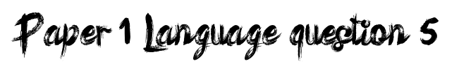 | Paragraphs
Planning | 10 minutes to gather ideas and plot events, character formation. Start, middle and ending. Know where your story will end up. How will I make it convincing and compelling? | Why use them? |  | To organise and structure your narrative.  To build on ideas and manipulate the response of the reader.  To guide your reader and place them where you want them.
Writing narrative | 30 minutes | When to use them? |  | Change of setting, time, mood.  To add impact to a line/word/event.
Proof reading | 5 minutes- this time is crucial | How to link them? |  | Adverbials, anaphora, connectives, use of time, a thread running through your narrative.
Assessment objectives |  | Ambition and originality?
AO5 | Communication and organisation. The actual plot. Character and setting. | How can I show this? |  | Your voice. Let your voice/personality spring from the page.
AO6 | Technical accuracy- punctuation, sentence structure, sentence variety, tense accuracy, ambitious vocabulary, spelling | Endings
Character |  | How? |  | Cliff hanger, repetition (cyclical structure), resolving crisis, a question.
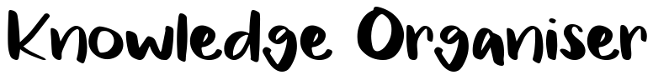  How many? | 2-3 Max. realistic and developed. Show me don’t tell me. | Why are they important? |  | Give the characters and the reader closure and demonstrates your ability to control your communication.
How to make them plausible? | Give them traits you can relate too. Consider creating a stock character to use in all your narratives. Make them 3D. be realistic about behaviours, relationships etc. Show me them. | Plausibility? |  | Voice needs to be maintained. Planned, not a rush ‘and then I woke up’ or ‘they lived happily ever after’. Needs to fit with narrative and plot.
Setting/plot |  | VSSSP (AO6)
How many? | 1-2 settings. Ideally one, well developed setting. Somewhere you know well and can bring to life. Needs to be realistic. Somewhere the reader can relate to. Plot needs to be relatively simple- you only have 45 minutes- and in a short time frame. Make it believable. | Accuracy? Tense? |  | Verb tenses need to be used correctly.  Past, present, future. Past tends to work best. Needs to be consistent throughout the narrative.
How to make it plausible? | Stick with relatable experiences. Use a situation you have experience of directly or indirectly. Somewhere you have experience of which you can ‘jazz up’ and amplify a little. Use senses to make a setting come to life so the reader can imagine themselves there. Don’t use film plots. | Effective VSSSP Proof read for spelling, omissions in words and errors in punctuation.  Basics must be accurate: . , ‘ “ “ ! ? and capital letters.  Use other punctuation sparingly. Don’t; overuse : ; ( ) … -  Vocabulary needs to fit voice and narrative. Ambitious but suitable.  Vary sentence structure. Use a range of simple, compound, complex. Vary where your subordinate clauses fall in your sentences. Vary sentence starters. Avoid a, the and an.
Timings |  |  | Paragraphs
Planning | 10 minutes.4 Annotate around the picture for ideas/vocabulary/senses/mood and atmosphere |  | Why use them? | To organise ideas across the description. To develop the description.
Writing description | 30 minutes |  | When to use them? | As you move around the picture. Change of mood or pace.
Proof reading | 5 mins to proofread |  | How to link them? | Adverbials, anaphora, connectives, use of time, a thread running through your description.
Assessment Objectives |  |  | Endings
AO5 | Communication and organisation. The structure of the description. How you organise and develop and control it. |  | How? | Link back to the start, tie up any loose ends to any threads, cliffhanger, a question.
AO6 | Technical accuracy- punctuation, sentence structure, sentence variety, tense accuracy, ambitious vocabulary, spelling |  | Why are they important? | Reader needs to have closure and it demonstrates you ability to control your writing.
Techniques to use |  |  | Your vocabulary bank
Show me, don’t tell me | Try to use figures if speech to describe. Avoid using ordinary nouns and instead use expanded noun phrases, metaphors etc- be more creative e.g. instead of Inside the market, you could say, inside the hustle and bustle of the heart of the town. This tells a reader so much more already.
Be like a camera | Start with a long shot of whole picture.  Zoom in on one area of the mage  Track across the image and zoom in on another area.  Zoom out to a medium shot  Zoom back in to a big close up.  This structure can be played around with in terms of order but provides you with a wide variety of possibilities.
Be in the image | Write in 1st person as if you are something in the image- the person, the wall, the chair whatever might be there. Show us the image from your perspective.

